INVITATION AND PROGRAM

3rd International workshop

The Hexapod System

An Addition to the Ilizarov Apparatus

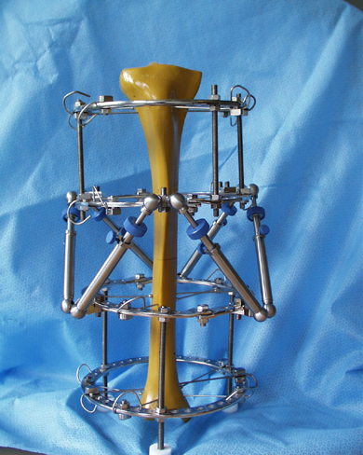

Thursday, September 25th and Friday September 26th

Hamburg, Germany

Berufsgenossenschaftlicher Verein für Heilbehandlung Hamburg e.V.

Berufsgenossenschaftliches Unfallkrankenhaus Hamburg

Arbeitsgemeinschaft Dynamische Osteogenese nach Ilizarov e.V.
Dear Colleagues,

in Feb. 2007 a first international workshop about the computer assisted 6 degrees-of-freedom precisely adjustable Hexapod Ilizarov fixator system was held in our hospital. There were intense fruitful discussions about six-axis-corrections with Ilizarov surgeons from many countries. Because of great interest in the hexapod, a second international workshop was held in March 2008 in Zerifin, Israel, and there is an additional demand for a 3rd workshop now.

We are looking forward to arrange it as an activity of the Arbeitsgemeinschaft (working group) Dynamische Osteogenese nach Ilizarov e.V.. Attendants of the workshop will be introduced into the application of the apparatus and the use of the software for fracture reduction and deformity correction in as much depth as possible.

Please be cordially invited to attend the Hexapod workshop at the Berufsgenossenschaftliches Unfallkrankenhaus (Trauma Hospital) Hamburg.

Prof. Dr. med. Ch. Jürgens Prof. Dr. med. Klaus Seide
Medical Director Workshop Organisation

Venue: Berufsgenossenschaftliches Unfallkrankenhaus (Trauma Hospital) Hamburg
Bergedorfer Strasse 10, D-21033 Hamburg, Germany

Information: Prof. Dr. Klaus Seide, tel. +49-40-7306-1616, Fax +49-40-7306-2799. email k.seide@buk-hamburg.de. To register, please send an email to this address with the content line “HEXAPOD WORKSHOP”

Kindly note, that the number of places is limited.

Fee: There will be a fee of € 250.-. Please send a check or transfer the amount after confirmation of your registration to

Berufsgenossenschaftliches Unfallkrankenhaus Hamburg,
Bank: Hamburger Sparkasse
Account number: 1039243702 IBAN: DE74200505501039243702
Bankleitzahl 20050550 BIC: HASPDEHHXXX

You are invited for the social dinner.

Accommodation: Good middle class Hotel close to the Hospital: Ramada Hotel Hamburg-Bergedorf., phone:. +49-40-72595-0, fax: +49-40-72595-187, email hamburg-bergedorf@ramada.de
Special price (refer to Berufsgenossenschaftliches Unfallkrankenhaus): € 76.- + € 15.- breakfast

Arrival by air: Airport Hamburg, taxi
Arrival by Train: Hamburg Hauptbahnhof, taxi

Program:

Thursday, September 25th

Introduction

9.00 Welcome (Ch. Jürgens)

  - Organisation (K. Seide)

  - Principles of the Hexapod System (K. Seide)

9.50 Workshop: Acquaintance with Ilizarov Hexapod set. Installation and dismantling
of the Hexapod

10.45 Coffee Break

11.00 Workshop: Controlling the Hexapod System without software application

12.30 Lunch break

13.30 Improving the traditional Ilizarov Apparatus with the Hexapod for deformity
correction and fracture treatment (Jacob Odessky, Zerefin, Israel)

14.00 Workshop: Application of the software, fracture model

16.00 Coffee break

16.15 Workshop: Generating a deformity for the next day

17.15 Diskussion

17.45 End of first day

19.30 Social dinner

Friday September 26th

9.00 Special frames (e.g., multilevel, foot, J. Odessky)

  - History and actual development (e.g., motor controlled external fixator, K. Seide)

9.35 Workshop: Deformity correction of frontal and sagittal plane deformities

11.15 Coffee Break

11.30 Workshop: Reduction of fractures by the Ilizarov Hexapod Apparatus

13.00 Lunch

14.00 Workshop: Correction of complex deformities

16.00 coffee break

16.15 Inversed program ( J. Odessky)

16.30 Discussion

17.00 End of second day

